**Setup:**

* **We need Visual Studio 2015 to execute the Tests.**
* **Download and Install the Visual Studio 2015 (**if it’s not installed**).**
* **Copy the zip file of the project into local drive of the machine.**

**Prerequisites:**

* **Copy the Attached excel into the local machine and give the path accordingly in the solution.**

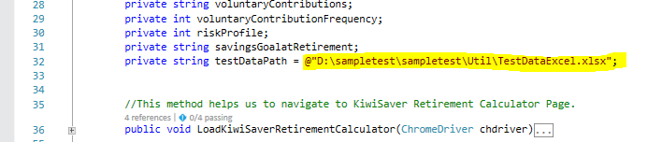

**Execution:**

* **To open the project using Visual Studio follow the navigation below.**

**Go to File 🡪 right click 🡪Open🡪Project/solution🡪 A pop-up window appears asking for the saved project (in the local) to be opened 🡪 Click on the Microsoft Visual Studio Solution🡪Click on Open.**

**Step 1:**

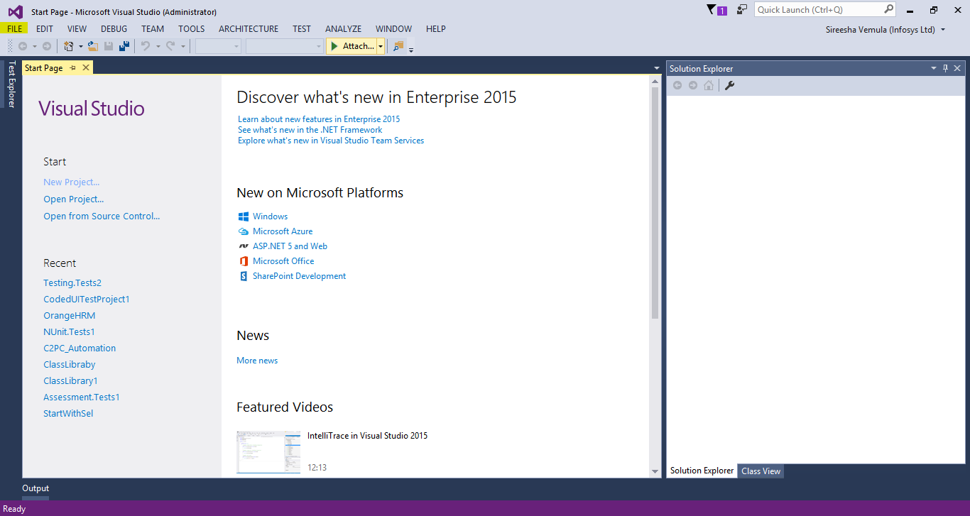

**Step 2:**

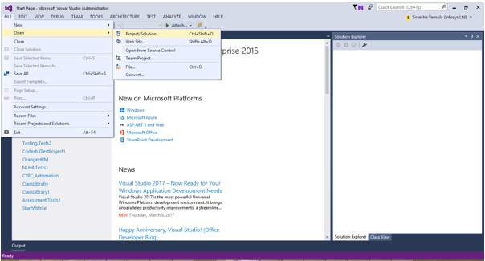

**Step 3:**

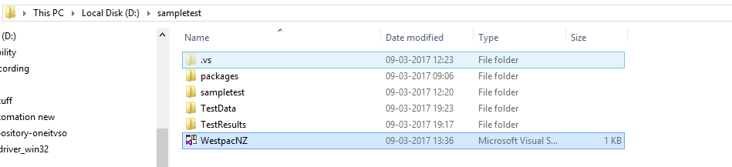

**Step 4: Go to the Solution Explorer of the project and Right click and make a click on the Build option to build the solution.**

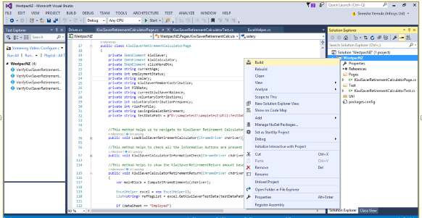

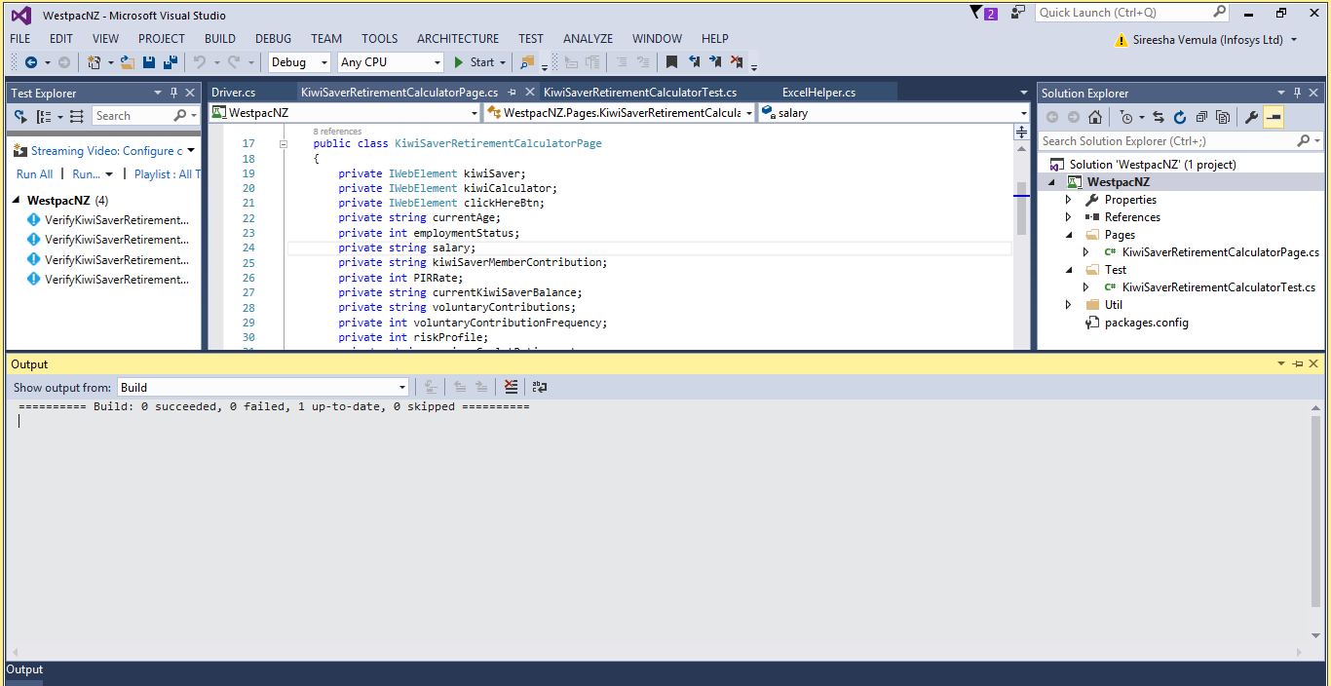

**Step 5: To run the tests, we need to go the Test Explorer and to achieve that follow the Navigation below.**

**Go to Test 🡪Right Click🡪Windows 🡪 Test Explorer (make a click).**

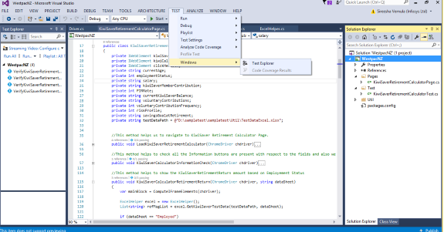

**To the right side of the Visual Studio window we can see the Test Explorer with all the list of respective Test Methods.**

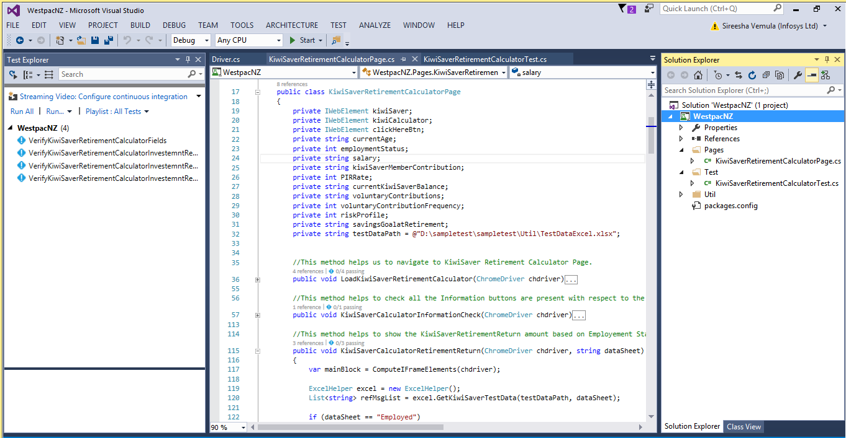

**To run all the tests click on Run All option.**

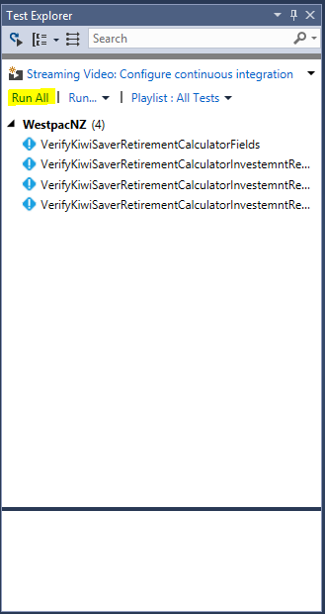

**To run any one particular Test. Right click on that particular Test Method and click on the option Run Selected Tests.**

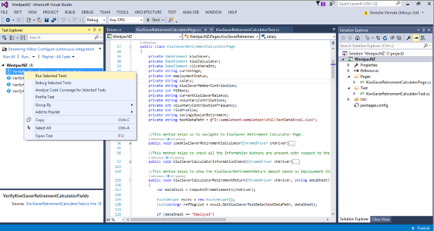

**After execution of the Tests the results will be shown as**

